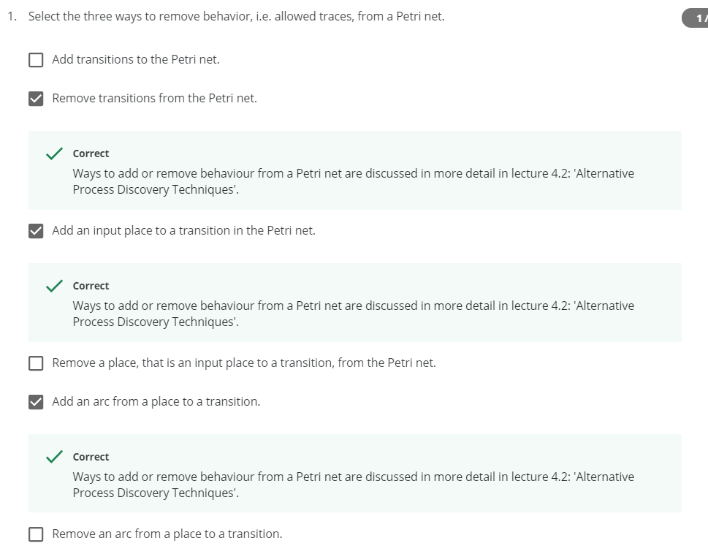

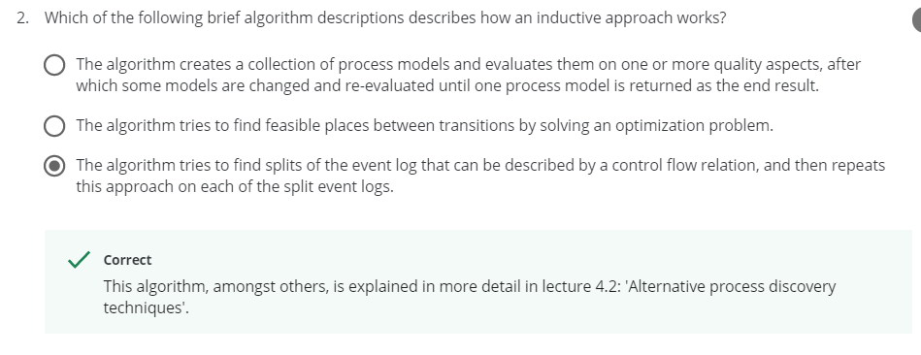

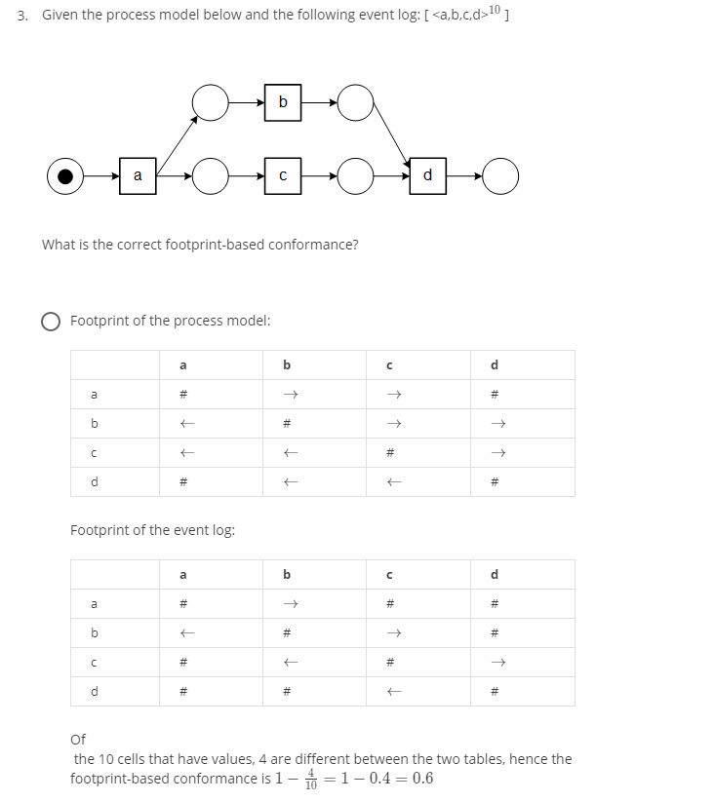

Footprint of the process model is wrong

# => It doesn’t follow either way

a🡪b => a follows b

b🡨a => a follows b

|| => Sometimes it follows by a or b

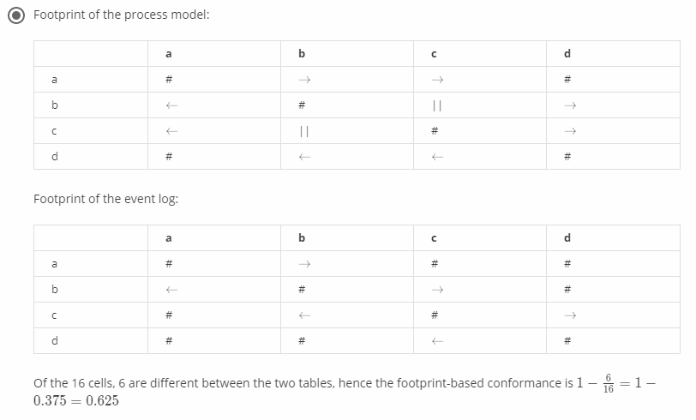

Footprint of the process model is correct

Conformance value also correct

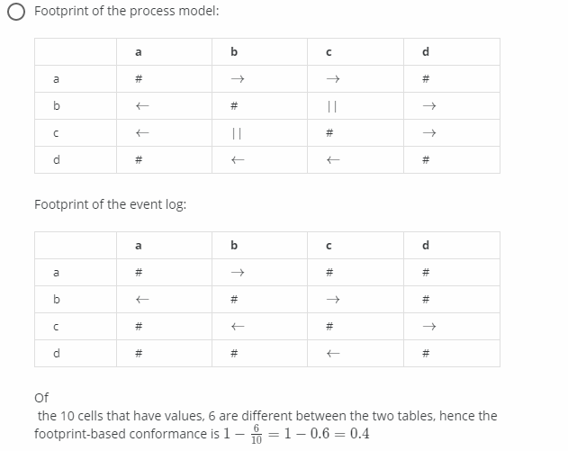

Footprint of the process model is correct but only taken 10 cells out of 16 considered for conformance checking formula

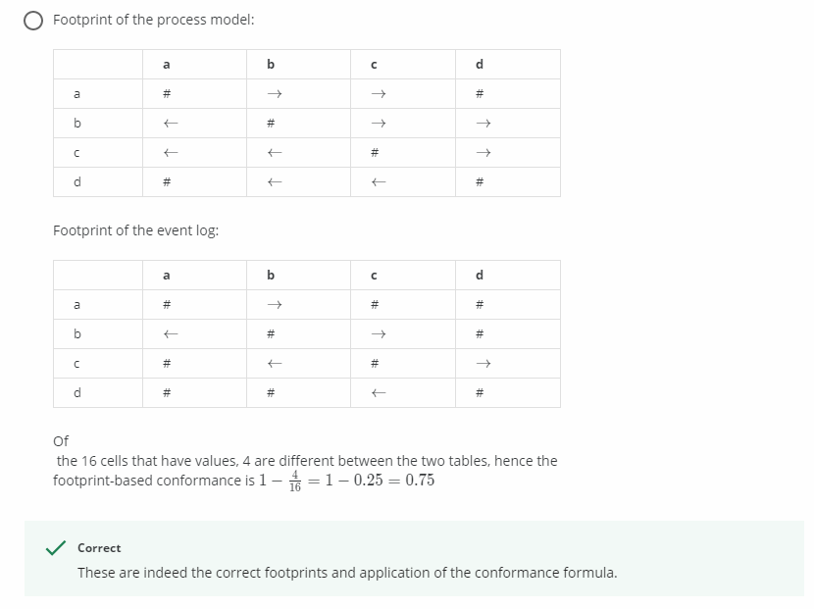

Footprint of the process model is wrong

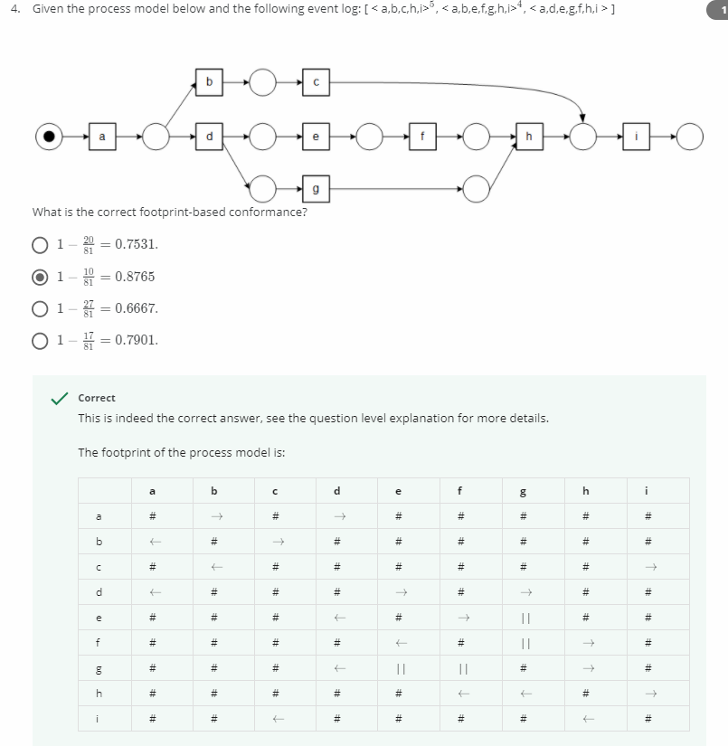

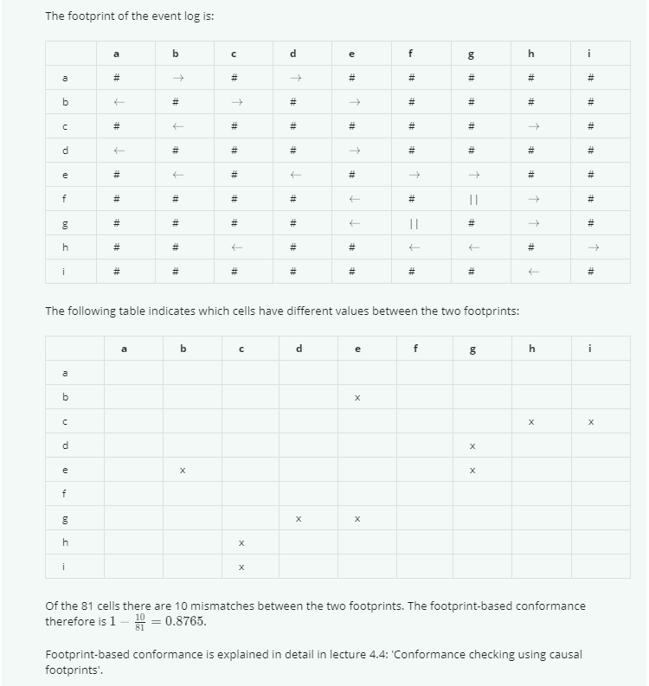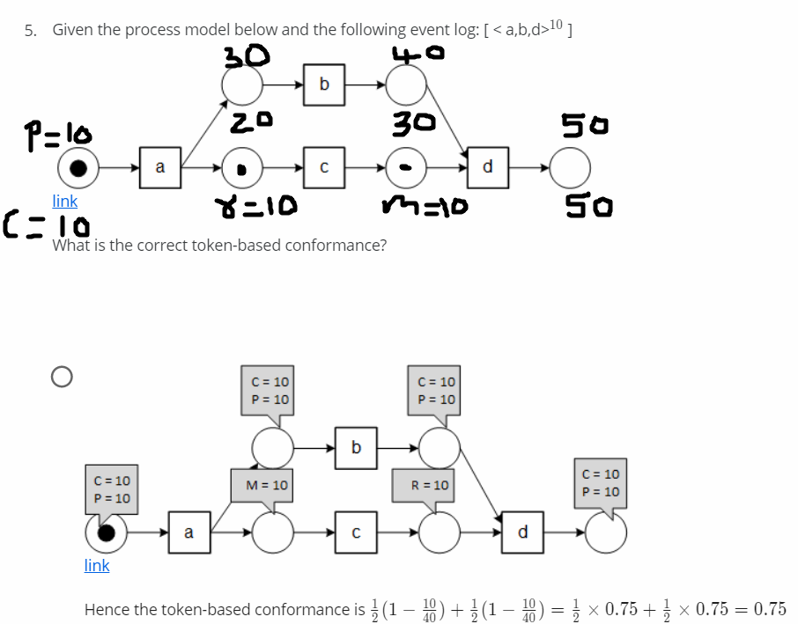

P => Produced Token

C => Consumed Token

R => Remaining Token

M => Missing Token

Token-based Conformance = ½(1-m/c)+1/2(1-r/p)

M and R positions are wrong

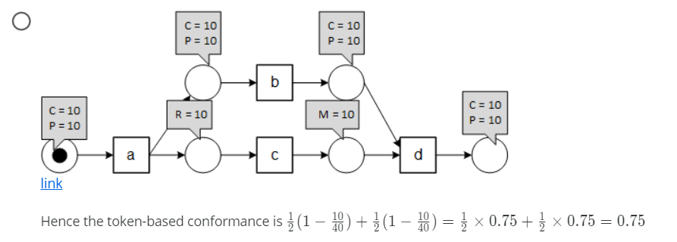

Produced and Consumed values are not there at R and M positions

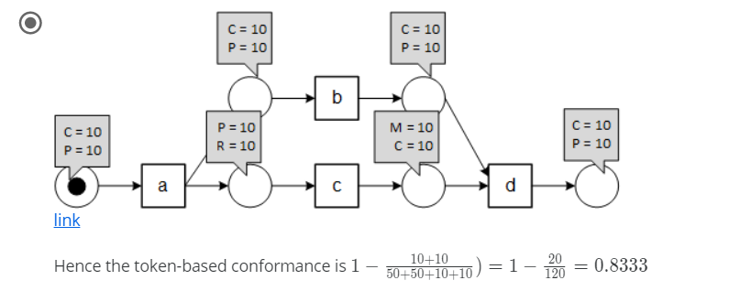

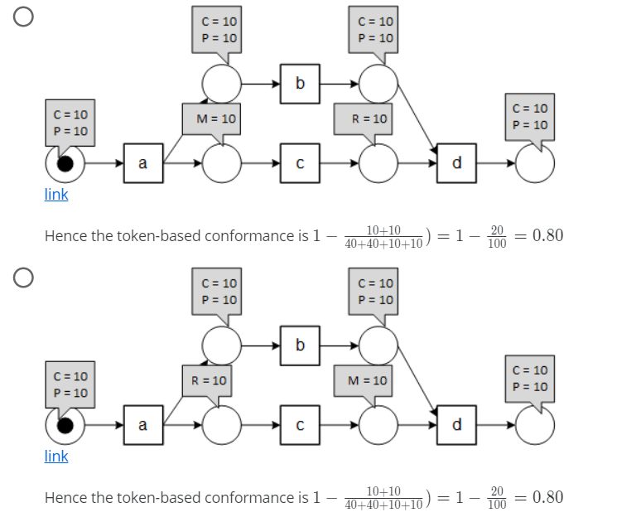

Formula is wrong

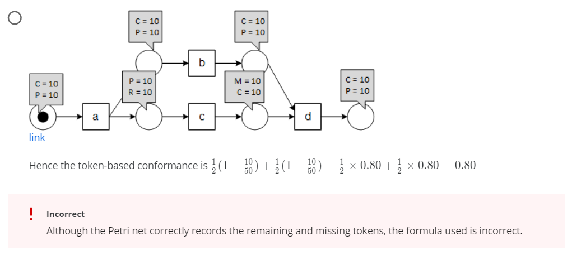

This one correct

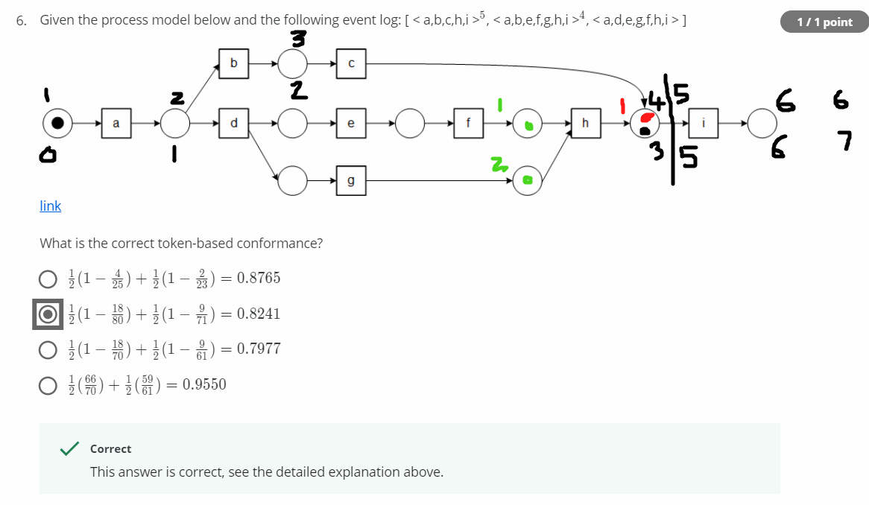

This is for <a,b,c,h,i>

P = 6 => 30

C = 7 => 35

M = 2 => 10

R = 1 => 5

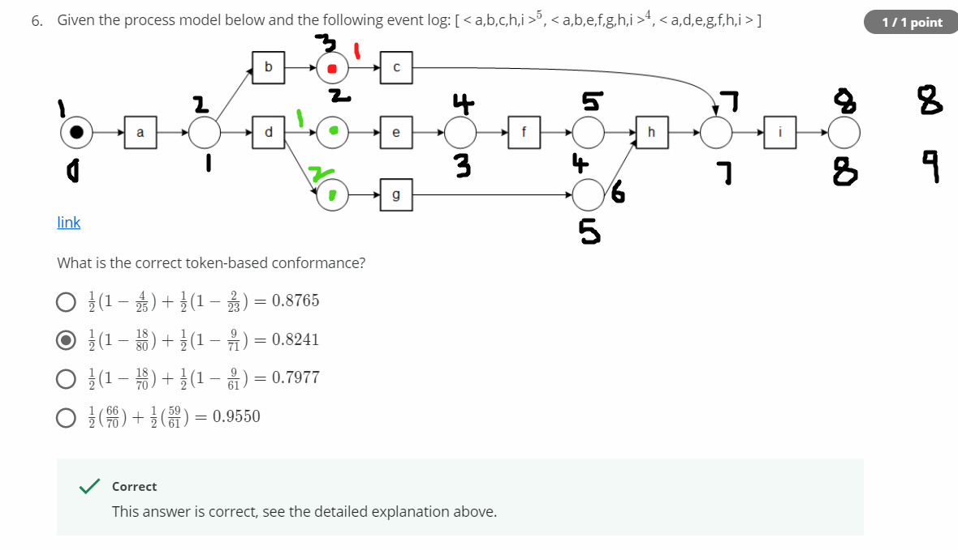

This is for <a,b,e,f,g,h,i>

P = 8 => 32 (Multiplied with number of times the trace has occurred)

C = 9 => 36

M = 2 => 8

R = 1 => 4

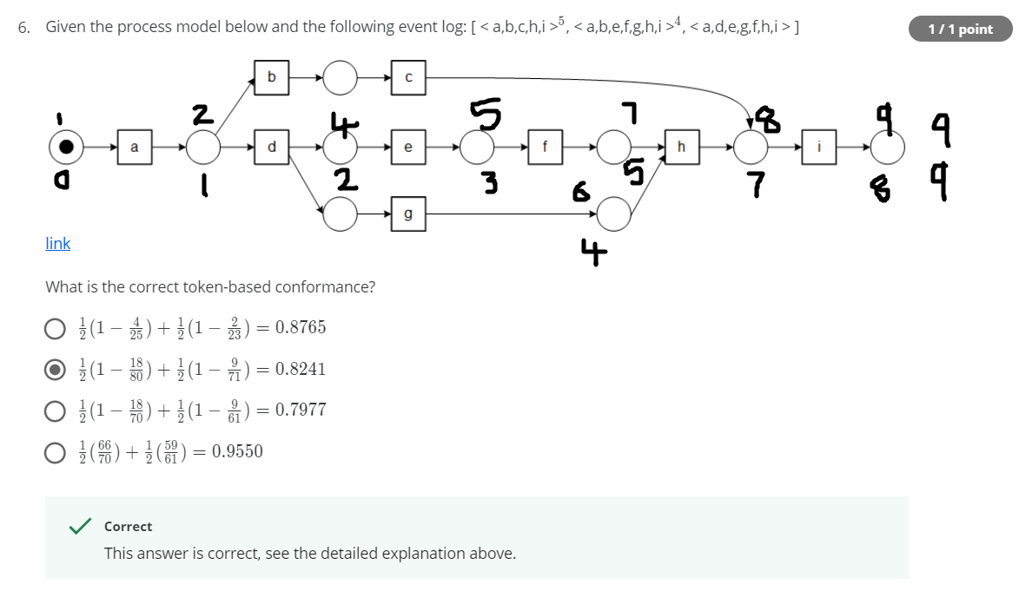

This one is for <a,d,e,g,f,h,i>

P = 9, C = 9, M = R = 0

Add all P’s => P = 9+32+30 = 70

Add all C’s => C = 9+36+35 = 80

Add all M’s => M = 8+10 = 10

Add all R’s => R = 5+4 = 9

Token-based Conformance = ½(1-m/c)+1/2(1-r/p)

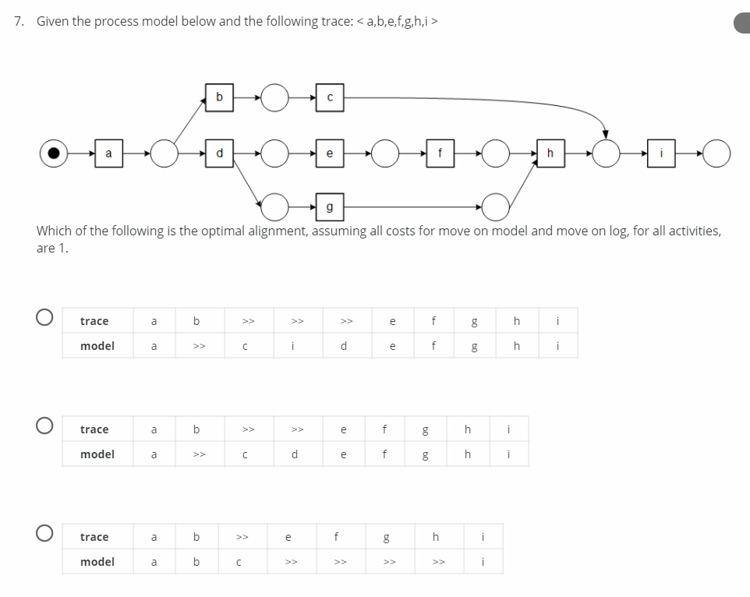

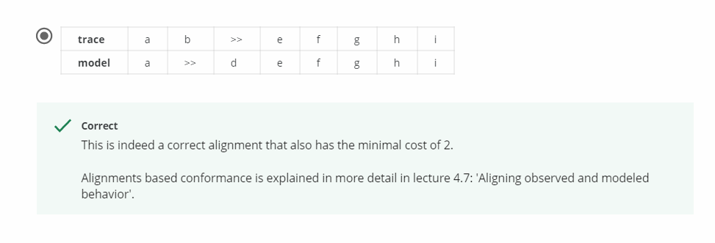

For third option: Correct alignment has cost of 5

First two options models are not possible

So last option is correct alignment with minimal cost of 2

